Title:

Report of Human AI-Collaboration in Generating Calming Art for Hospitals (Using Both Pretrained and Scratch Trained Models)

By: Natalie Fong

Abstract

In hospital areas dedicated to chronic disease or recovery, the atmosphere can often be disquieting. Patient studies indicate a preference for specific artworks that can effectively enhance calmness and mood. This project aims to expand the selection of such artworks by utilizing both scratch-trained and pre-trained models, guided by human input. The methodology involves identifying key characteristics of artwork known to evoke calesss, including subjects and color palettes. Image synthesizers are then employed to generate images, which are filtered to meet the predefined criteria of calmness based on research findings. Finally, various generative adversarial network techniques are employed to augment and diversify the collection of artworks.

1.1 Introduction

When thinking about the hospital, whether it is for a short stay or being bedriven there from chronic diseases, a lot of people think of a very disquieting and uncomfortable place which could be reflected through Figure 1. Monotonous with the repetition of a bed and medical equipment and white walls covering the room, it is difficult for a more comfortable atmosphere to be created. However, it could be seen in Figure 2 that just by adding a painting and some colors, the atmosphere of the room has seemingly ameliorated.

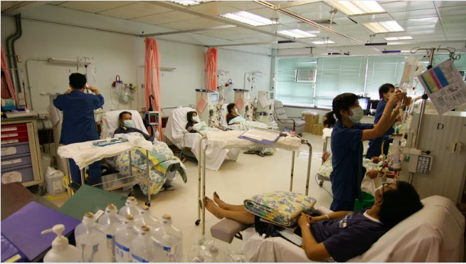

*Figure 1:* *Photo of a standard hospital in Hong Kong*

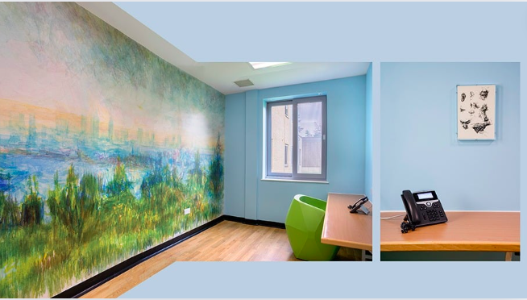

*Figure 2:* *Image example of a hospital room with paintings*

This matter has been further investigated. According to Dr. Staricoff’s study done upon 91 patients between the ages of 20-90[1] 80% reported that art improves mood; 47% found art effective in distracting themselves from medical worries; 65% claimed that it eases stress levels. 87% have also claimed that visual arts is the key and main element for rendering a “pleasant environment. Currently a lot of artworks are produced by renowned painters including, Mary Fedden, Julian Trevelyan, Lisa Milroy, Keith Grant and more according to organizations such as imperial health charity[2]. Being able to obtain artworks from renowned artists for the hospital is a very positive thing, as professionals in charge are able to choose from a pool of ready artworks and request to have them displayed in the hospital with the consent of the artist. However, according to another source, some artists are reluctant to commission artworks for the hospital. This is due to the fact that they are “concerned for the safety of their artworks”[3] and some reported that no “maintenance has been performed on their artworks as promised”. Therefore, there is a limited pool of artworks coming from renowned artists.

However, there are other sources for hospital art to be generated: from the general public or people that volunteer to paint paintings or murals for the hospitals. These are all amazing ways for generating art for the hospital. However, another study conducted by the National Library of Medicine[4] Out of a pool of 3707 art pieces from the art catalog of the Danish art museum, 20 art pieces were narrowed down and have been presented to 103 patients of different age groups which can be referred to in figure 3, only 5 were selected as their favorite art pieces. The patients have selected 1,2,3,5, 20 as their preferred paintings, where ⅘ of the paintings are a landscape. This reflects how although anyone can volunteer to create art for the hospitals, artsworks may not always have the same calming effect on the patients and be preferred by them.

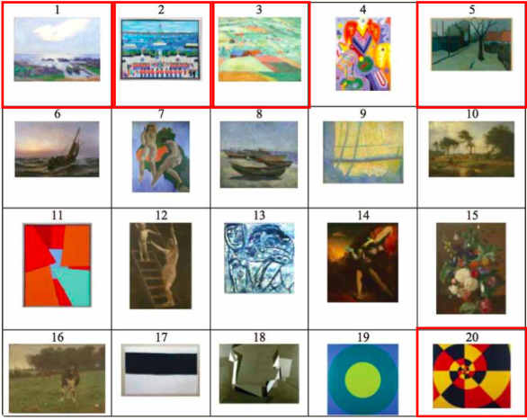

*Figure 3:* *20 painting used for research by the National Library of Medicine*

This leads to a design problem. I strive to create a project that has the aim to expand the selection of such artworks through using Ai, both scratched trained and pretrained models to explore different ways for art generation, yet guided by my human input. The artwork generated has the goal of both acting as a blueprint of inspiration for volunteers to follow to create artworks that are objectively more calming throughout different genders and age groups. Secondly, the generated art could potentially be printed out and be used in hospitals even if there are a lack of volunteers to paint artworks, which although less effective without the worthy of admiration element of paintings, could potentially still help to alleviate the hospital mood on a smaller degree.

1.2 Methodology

To execute this project, 3 methods would be used which could be referred to in Figure 4. This first method would be the most basic of converting text to images through an Ai text to image generator. This method would have a larger focus on research of gaining the correct keywords as a prompt to generate images that are calming, setting a good foundation for the project. However, Ai generator is less precise in a sense where many images which are very diverse would be generated upon using one keyword. This is a great way to brainstorm a lot of clear images very quickly, however, it would be hard to control the output into exactly what is wanted based on research. Thus, the second and third method which is a scratch-trained model is used in order to explore more various ways to have more control over the output. Additionally, 3 types of Ai tools would be used which could be referred to in Figure 5. This includes an Ai image generator which is a text-to-image ai generator. Next, an Ai vision would be used, generating a description from an image. Lastly, a neural network would be used which would be GAN.

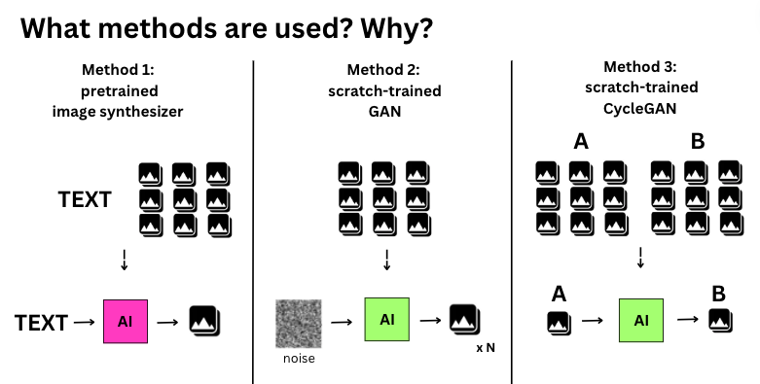

*Figure 4:* *Diagram demonstrating the methods used*

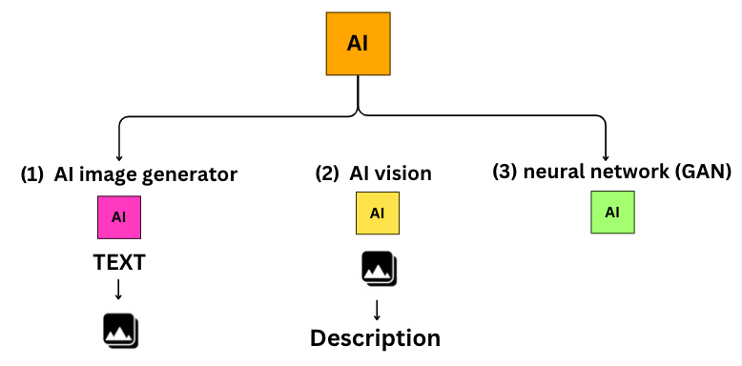

*Figure 5:* *Diagram demonstrating the Ai used*

As for the pipeline of the project shown in Figure 6. The project would begin through researching characteristics of subject matters that are calming through reading academic journals. The research would then be organized into a table where keywords would be exerted for prompt for the text-to-image generator. Around 50 images would be generated from the research which would be narrowed down to a few images best fitting my research after running through some assessments. Based on the qualities of these narrowed down few images, more images, over 500, would be generated through the text-to-image generator. These 500 images would then be used as the input dataset for GAN. Yet throughout the process, some assessments would be run in between to enhance the reliability of some of the outcomes which are originally more subjective.

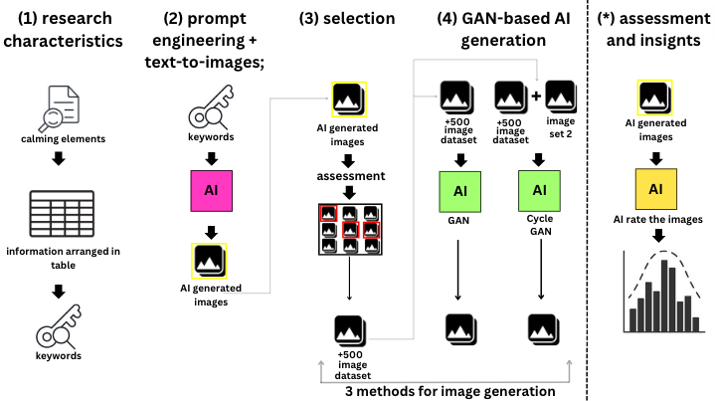

*Figure 6:* *Diagram demonstrating the pipeline of the project*

1.3 Research for keyword generation

In regards to the research of aspects that allows artworks to be calming. According to thea study conducted by Roger S. Ulrich[5]The study group expressed their liking for both landscape and nature sceneries. This is “consistent with certain evolutionary psychological theories, which predict positive emotional responses to flourishing natural environments.” Additionally, according to another academic study[6] conducted by several researchers **on** 27 university students, a more objective conclusion was deduced. The outcome reflected how plants including bonsai trees, foliage plants, or flowers in general are effective in having relaxing effects on the brain through observing autonomic nervous systems. Another study[7] The National Library of Medicine conducted upon 19 female university students also shows that visuals of roses were affected in “ a significant decrease in oxy-Hb concentrations in the right prefrontal cortex” which is associated with increase of perceptions regarding feeling comfortable and relaxed, as well as an improved mood state.” Regarding the reasoning behind why landscapes are generally more preferred over portraits, according to an article[8] This is due to the fact that complex human emotions including presented through an artwork may potentially be absorbed by the viewer. This increases the potential probability of negative or feelings of ambivalence to be induced from deviating viewers from their calm state. Other than that, one more study[9] conducted upon 43 women and 40 men ranging from 20 to 90 years of age suggested that greens and blues increased relaxation and calm feelings of participants compared to the other colors. Similarly, expectant mothers in specific also prefer aquatic or earthly colors. Upon conducting these research, the key information would be highlighted as well as the keywords, then organized in a table as seen in the image below.

The table can be seen in the image below in Figure 7, where it is divided into sections of keywords, who the research is conducted on, information of the source (backing up the keyword), and also the source of where the information is from. From these information keywords are drive to be used as a prompt for the text to image generator generating around 50 images.

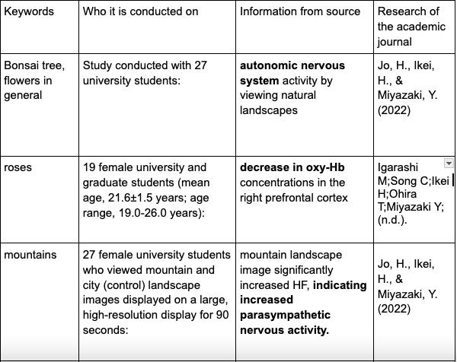

*Figure 7:* *Partial section of the table containing information of my research*

1.4 Different methods for image generation and assessments

For more information on a brief summary of how assessments are done which would be referred to in Figure 8. The 50 images generated from Ai image generator would be scored by an AI vision based on some specific questions. Images with a higher score for these questions would be filtered out. The qualities of these filtered out images would then be exerted with the help of Ai for even more keywords to be generated, which would be used to generate 500 plus images as input of GAN.

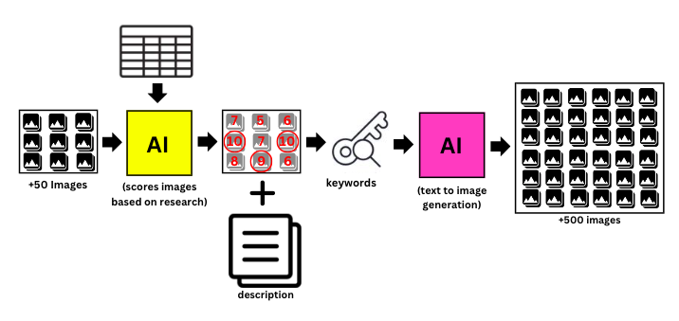

*Figure 8:* *Diagram to demonstrate the details of the pipeline*

Having generated around 50 images from an Ai image generator, as the images come in different sizes, a coding was involved for the images to be resized to the format of 256 x 256, squares to be further used for other purposes in the future. The resized version could be seen in figure 9. Proceeding, using Ai 2 questions were asked including A: “rate this image based on how much it matches the description of my research on a rate of 1-10” and B:“ rate this image for it’s calmness and ability to improve mood on 1-10”, where two scores would be generated for both A and B. These images with a high score for both would be selected to proceed which are highlighted in red in Figure 9.

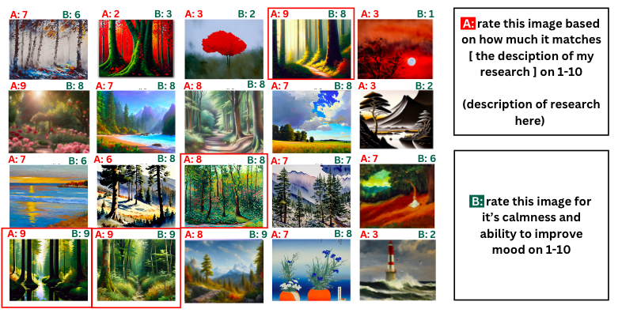

*Figure 9:* *Diagram to demonstrate the selection of images*

Regarding question B, due to the fact that asking Ai to rate an image out of its “calmness” is very subjective, another assessment of histogram is performed. Using jupyter notebook, I have created some codes that perform an analysis on the color pixels of “each image that has a high score for calmness, which would be images scored 9 and 10 seen in Figure 9. An extract of the code that used to execute the histograms can be seen in Figure 10. These codes are created under the guidance of chart gpt with some alterations from human input for the function to be executed. The code provided an analysis of the color pixels of the “images with a high calming score” based on its red, blue and green pixels separately, and as it could be seen in figure 11. The X axis would be the intensity of the color while the Y axis would be the number of color pixels of that color. Thus, the histogram analysis of Figure 11 would reveal that the image has predominantly light colors for all three colors, where there are more greens and blues in the image for moderate color intensity of blue and green tones in comparison to reddish tones (including orange, pink). All images with a score of 9 and 10 would have it’s own histogram analysis.

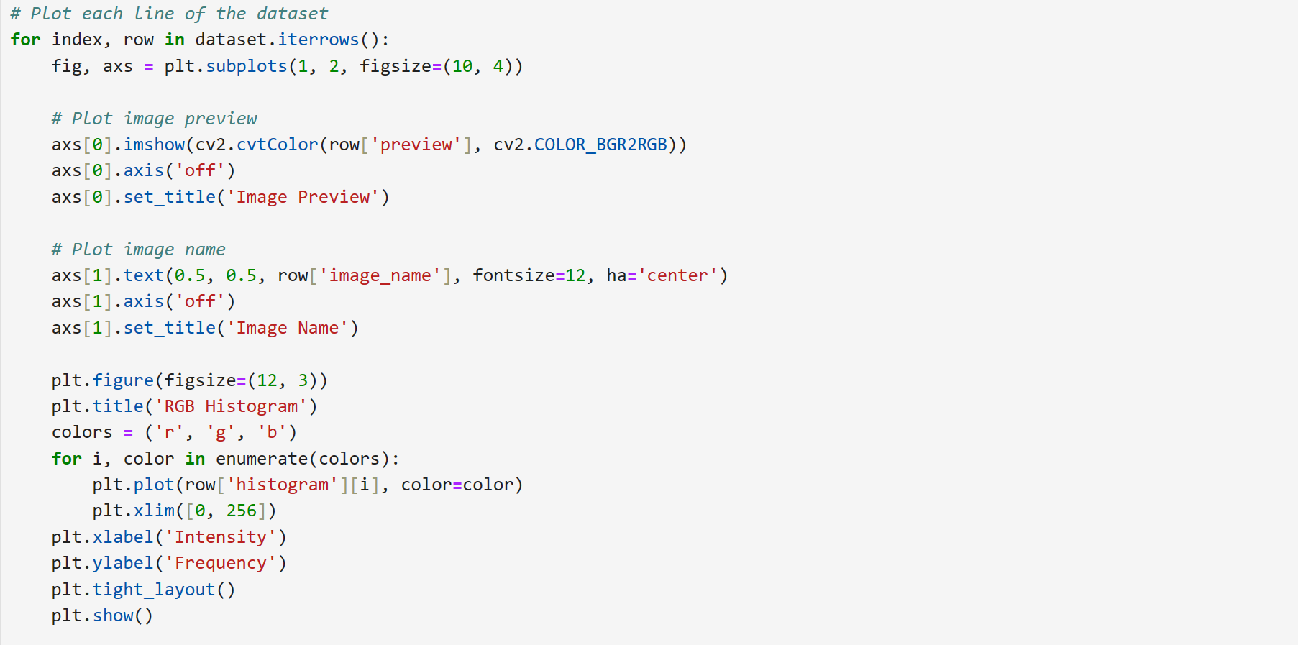

*Figure 10:* *A section of the code to execute the histograms*

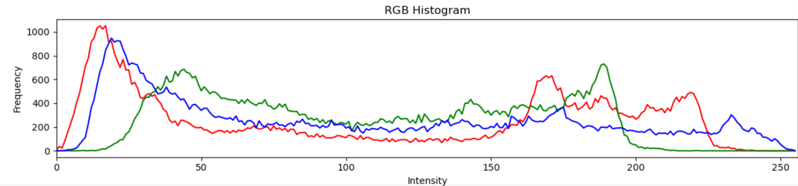

*Figure 11:* *Histogram analysis the color pixels of 1 image*

These histogram analysis would be overlapped together, which is done by another code guided by Chartgpt as seen in figure 12. This code is dedicated to have the analysis of histogram of each image overlapped together in accordance to the colors of red, blue and green, which is seen in figure 13. It is important to note that resolution of the images has been synchronized for the analysis to be more accurate, and it has also been separated into 3 colors. As seen from the results of figure 14, when all the analysis of all color and all selected images are presented together it is more chaotic for obvious insights to be seen. Most importantly, when the resolution of each image is different, the data of the histogram is highly inaccurate with no insights revealed. Thus, figure 13 was an improved version where clear insights could be exerted.

The results from Figure 13 reveal that for the color of blue and green, although there are more color pixels on the lighter side (on the left of the graph), there are also plenty of color pixels for the color tones with medium intensity ( a lot of darker shades of blues and greens and not limited to light colors). For the color pixels of red contrarily, it only reveals a higher number of pixels on the lighter intensity of the color red, meaning colors that are pastel orange or pink. However, there is an outlier as seen which could possibly be the colors of certain plants. Yet collectively there are not a lot of color pixels on the far right, signifying intense colors. Therefore, a common pattern as described could be deduced which also matches my research of having predominantly blue and red, and earth colors.

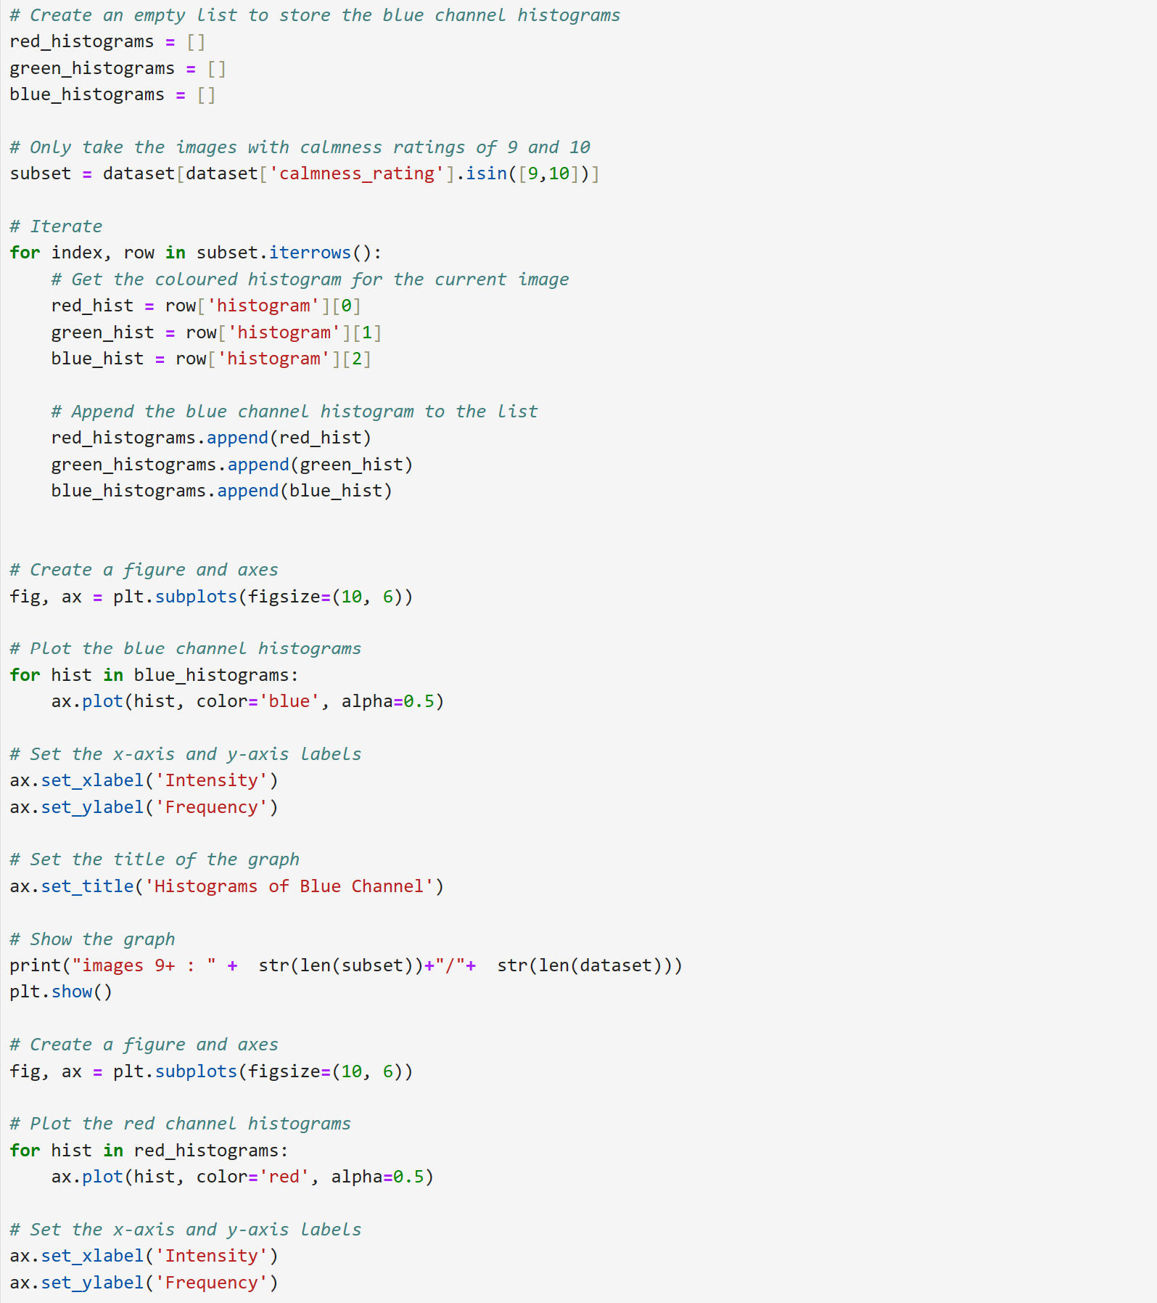

*Figure 12:* *A section of the code to execute the overlapping of the histograms*

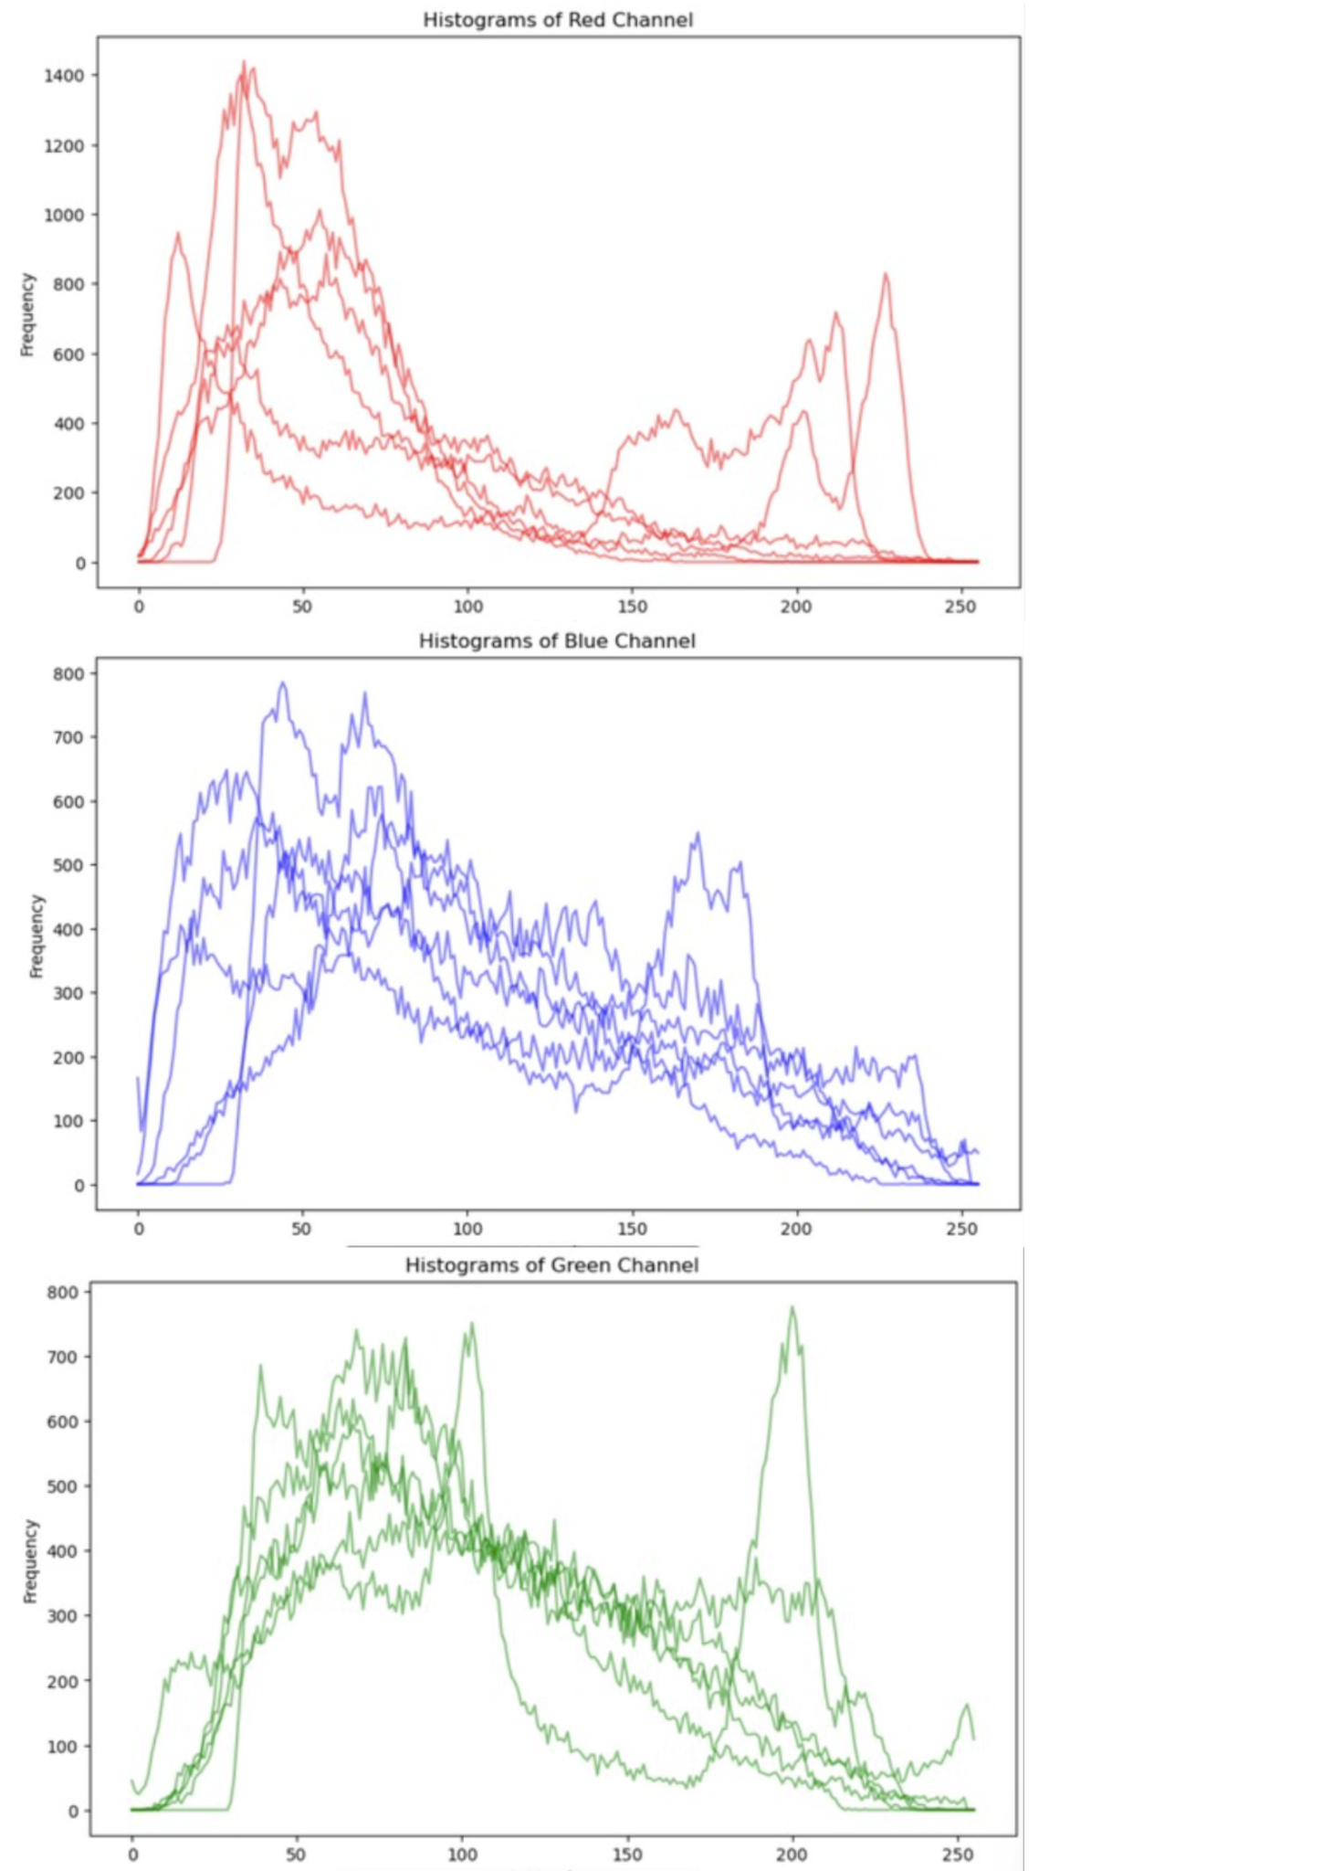

*Figure 13:* *Histogram analysis the color pixels of multiple images overlapped together*

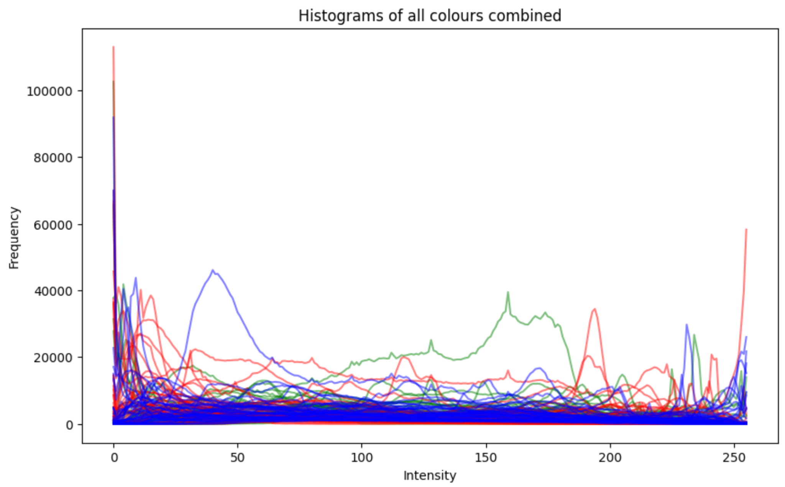

*Figure 14:* *An error of histogram analysis*

As for question A that appeared in Figure 9 mentioned above, referring to Figure 15, when asking Ai to rate the image based on how much a specific image matches the research, the keywords derived from previously executed research from Figure 7 would be used, for instance subject matter including “ forest, foliage plants, roses, and more”. These keywords acts as a benchmark for the Ai to score the images. Additional to this prompt an image generated by Ai (shown in Figure 9) is used as an input for the Ai vision. Upon executing the analysis, the more the image matches the description of the keywords, the higher the score would be. As seen in "Answer from AI section”, not only scores but provides a reasoning for why AI has produced that score. I would then paste the description into AI and prompt it to “narrow it down to only 10 keywords” leading to “Description <keywords” section. An enlarged version revealing more details can be referred to in Figure 17. In this Figure, it could be seen there are repetition of keywords, including trees, river, clouds, sky. These recurring keywords would then be extracted as a prompt for more image generation through an AI image generator. Including the initial keywords generated in the first round from above, together with these newly generated keywords, a larger word bank of keywords for Ai image generation is rendered.

A segment of the code that allows all keywords generated by Ai to be organized and listed in a table is shown in Figure 16, which leads to the table of 17. This allows all keywords to be seen side to side together, allowing the recurring keywords to be easily identified

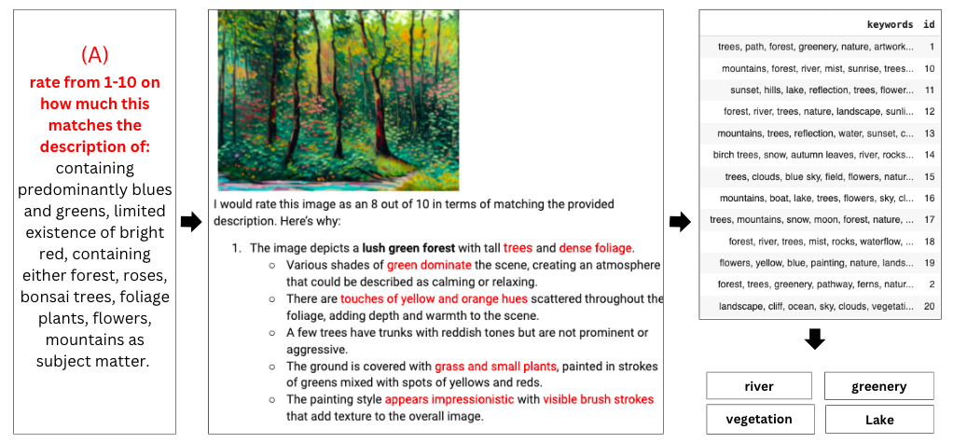

*Figure 15:* *Keywords generation process*

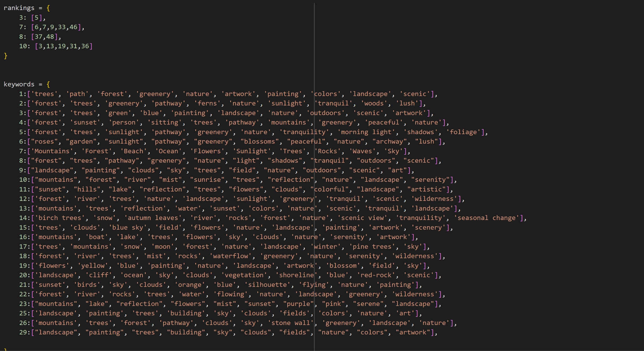

*Figure 16:* *Code snippet to store keywords data into a table*

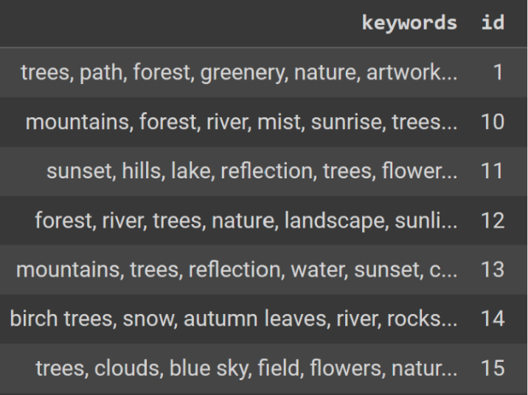

*Figure 17:* *A list of keywords derived from paragraphs organized into a table*

Figure 18 shows a sample of a segment of the 500 images generated from Ai image generator from the keywords of Figure 18.

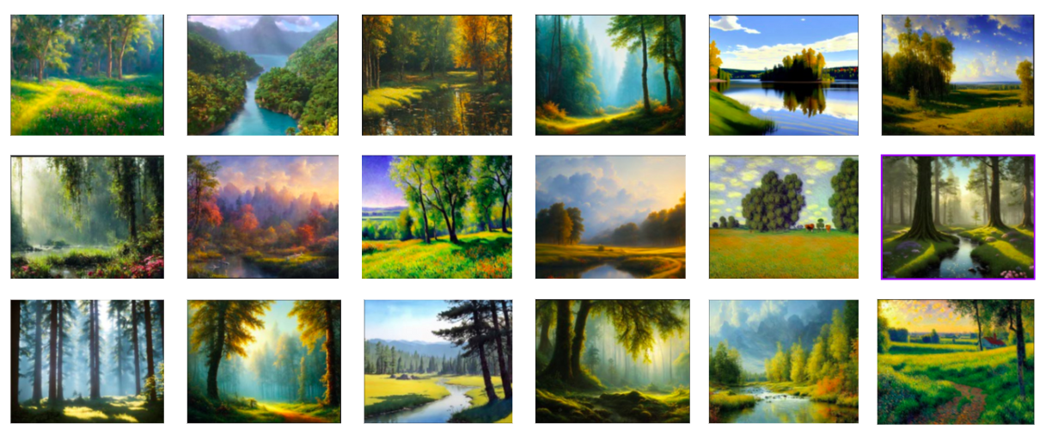

*Figure 18: Sample images generated by AI*

Regarding the way these images would be used as the input data of GAN, referring to Figure 19, in simple words GAN is a model that needs to be trained. In the training process, it involves a generator which learns to turn noise into something that captures the quality of the input image dataset which in the case of this project would be the calming images in Figure 18. A bunch of new images that have the qualities of the original dataset (Figure 19) would be generated. Oftentimes, to produce an output GAN ends up blending the elements of the original image as outcome.

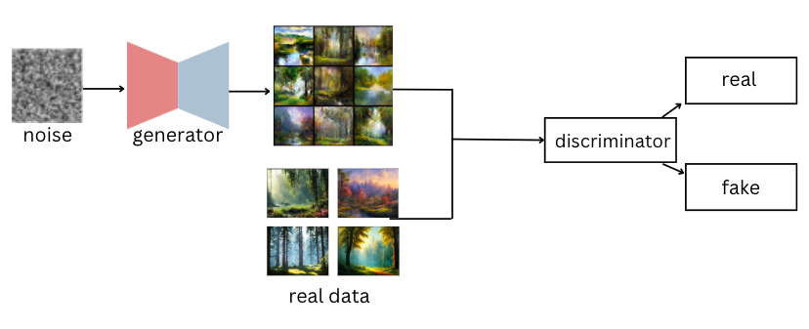

*Figure 19: Diagram for GAN*

Figure 20 and 21 provides a sample of the code of the generator and discriminator which is a big part of the code that allows GAN to function. The overall code was retrieved through kaggle with minor modifications including the file name of the input images for the output to be executed.

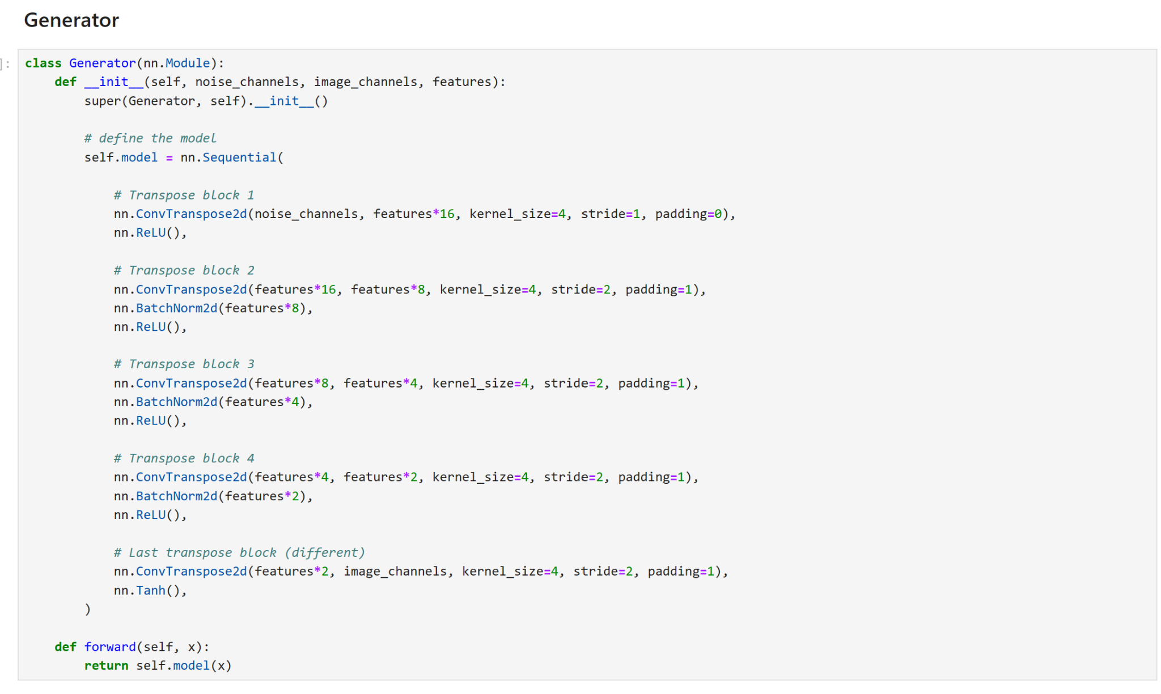

*Figure 20: Python class for GAN Generator*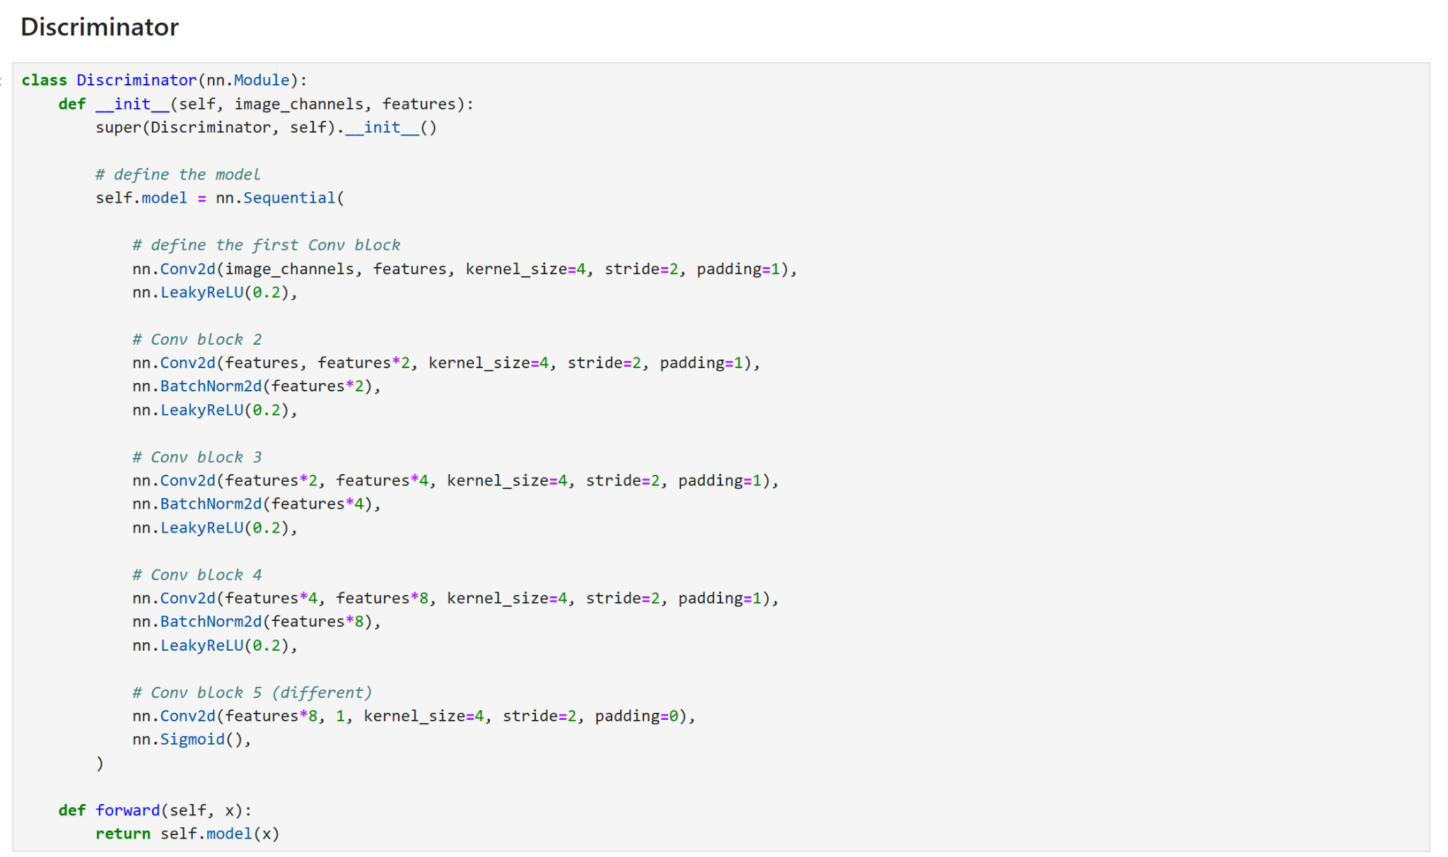

*Figure 21: Python class for GAN Discriminator*

Figure 22 to Figure 24 demonstrates the transformation that the input goes through for an output to be generated, going from a bunch of noise to clearer images, it can be seen that by the time the training reached the stage of Figure 24, some faint elements of nature like subjects have emerged.

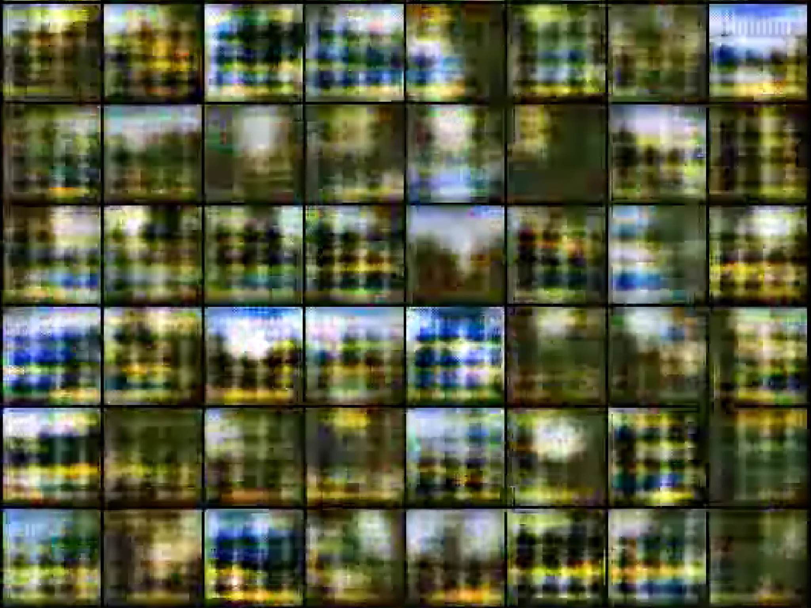

*Figure 22: Image revealing the training process of GAN at below 100 epochs*

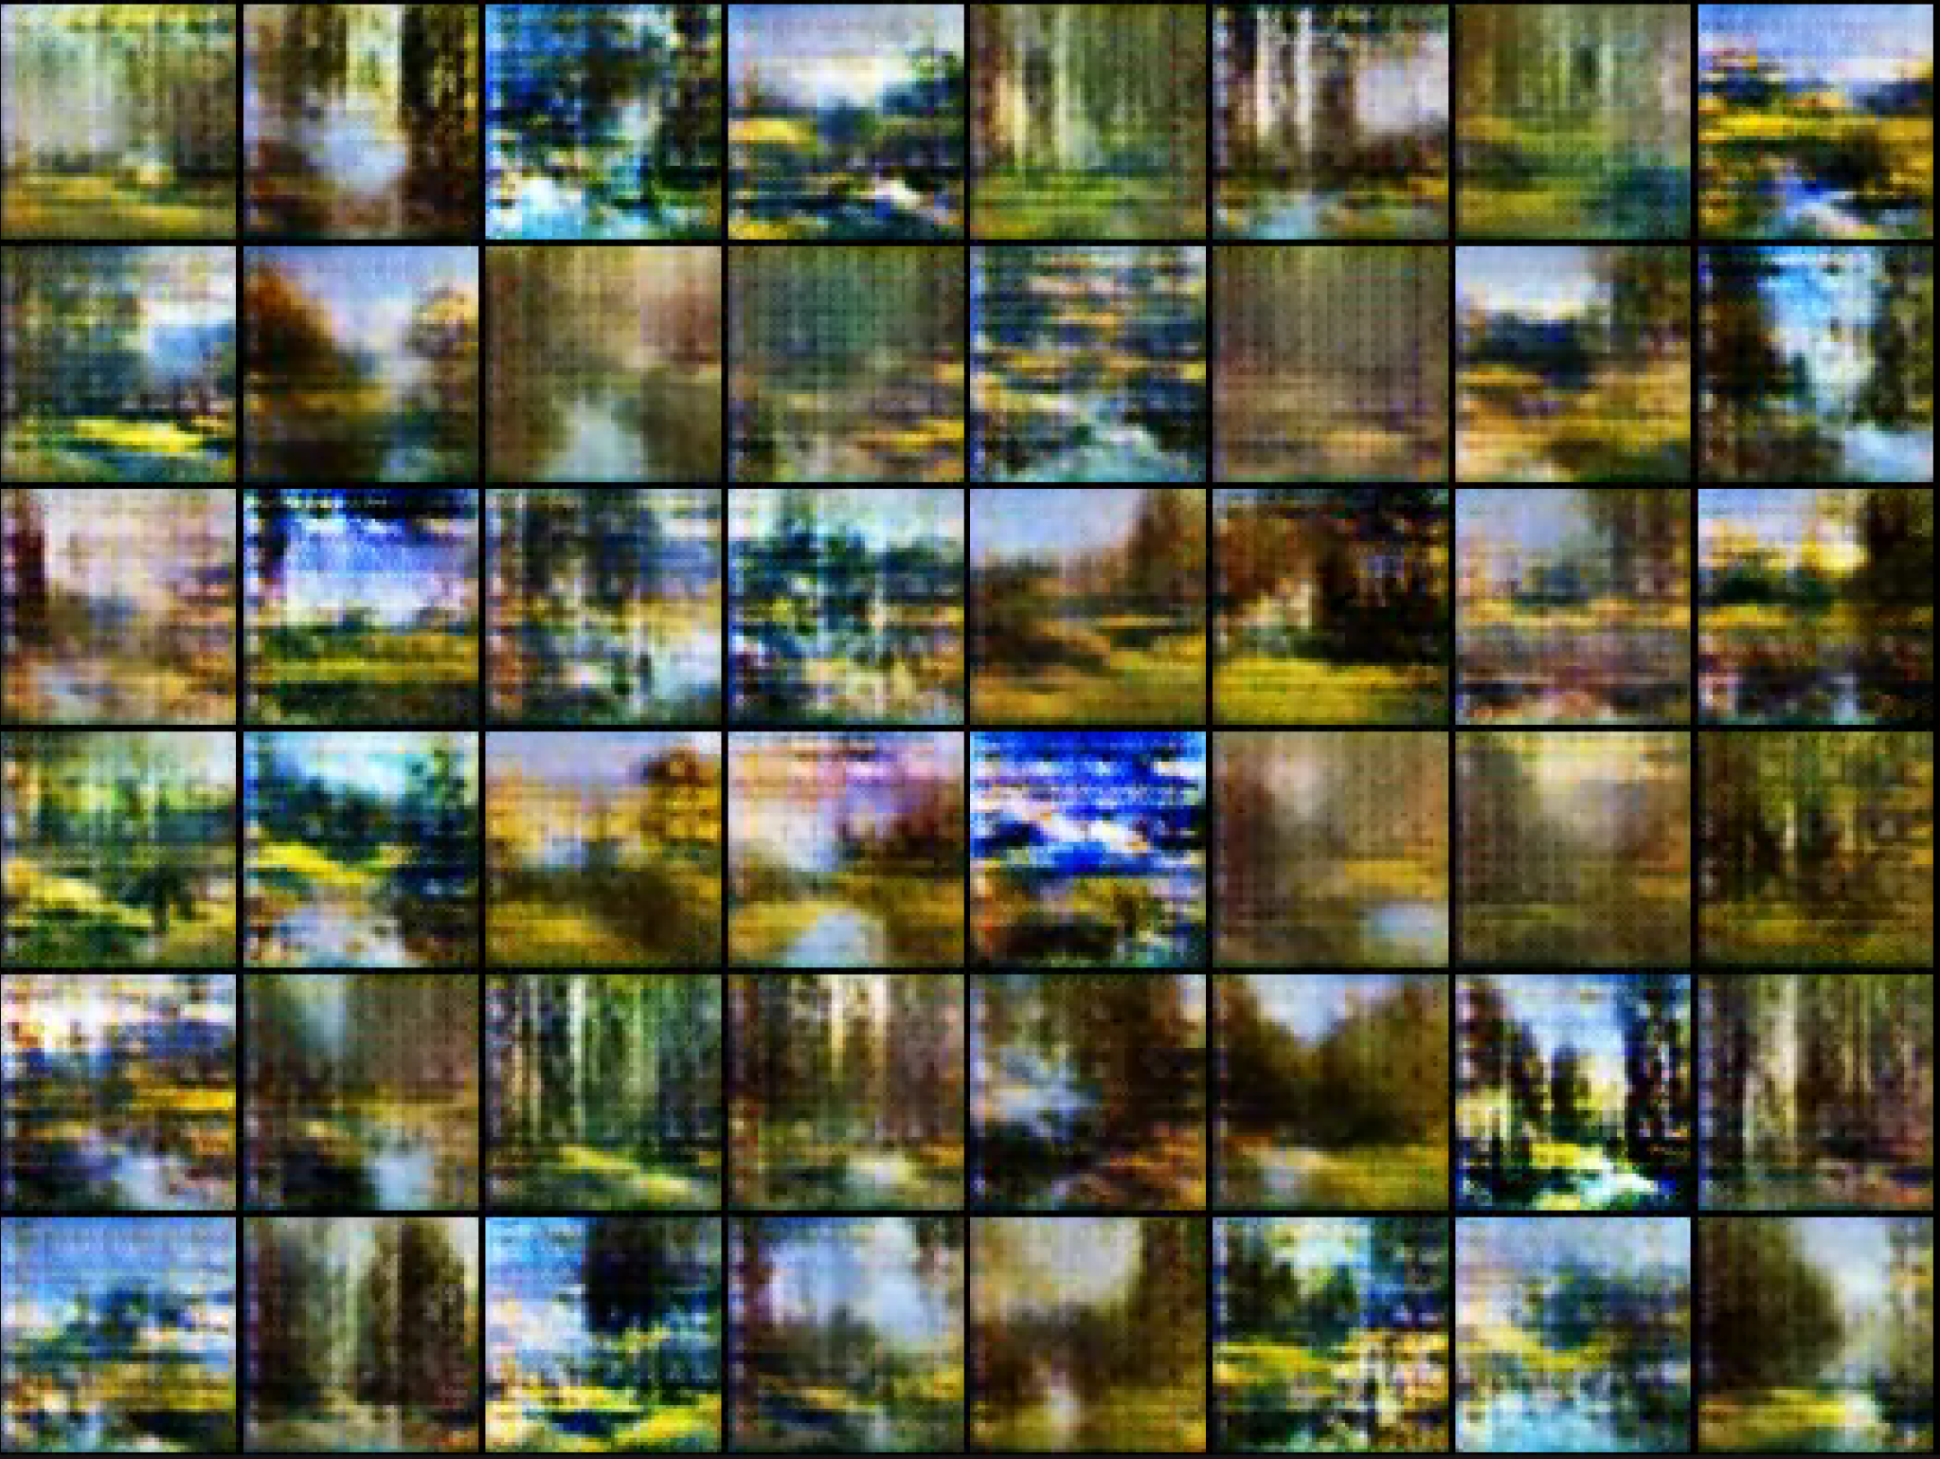

*Figure 23: Image revealing the training process of GAN at over 200 epochs*

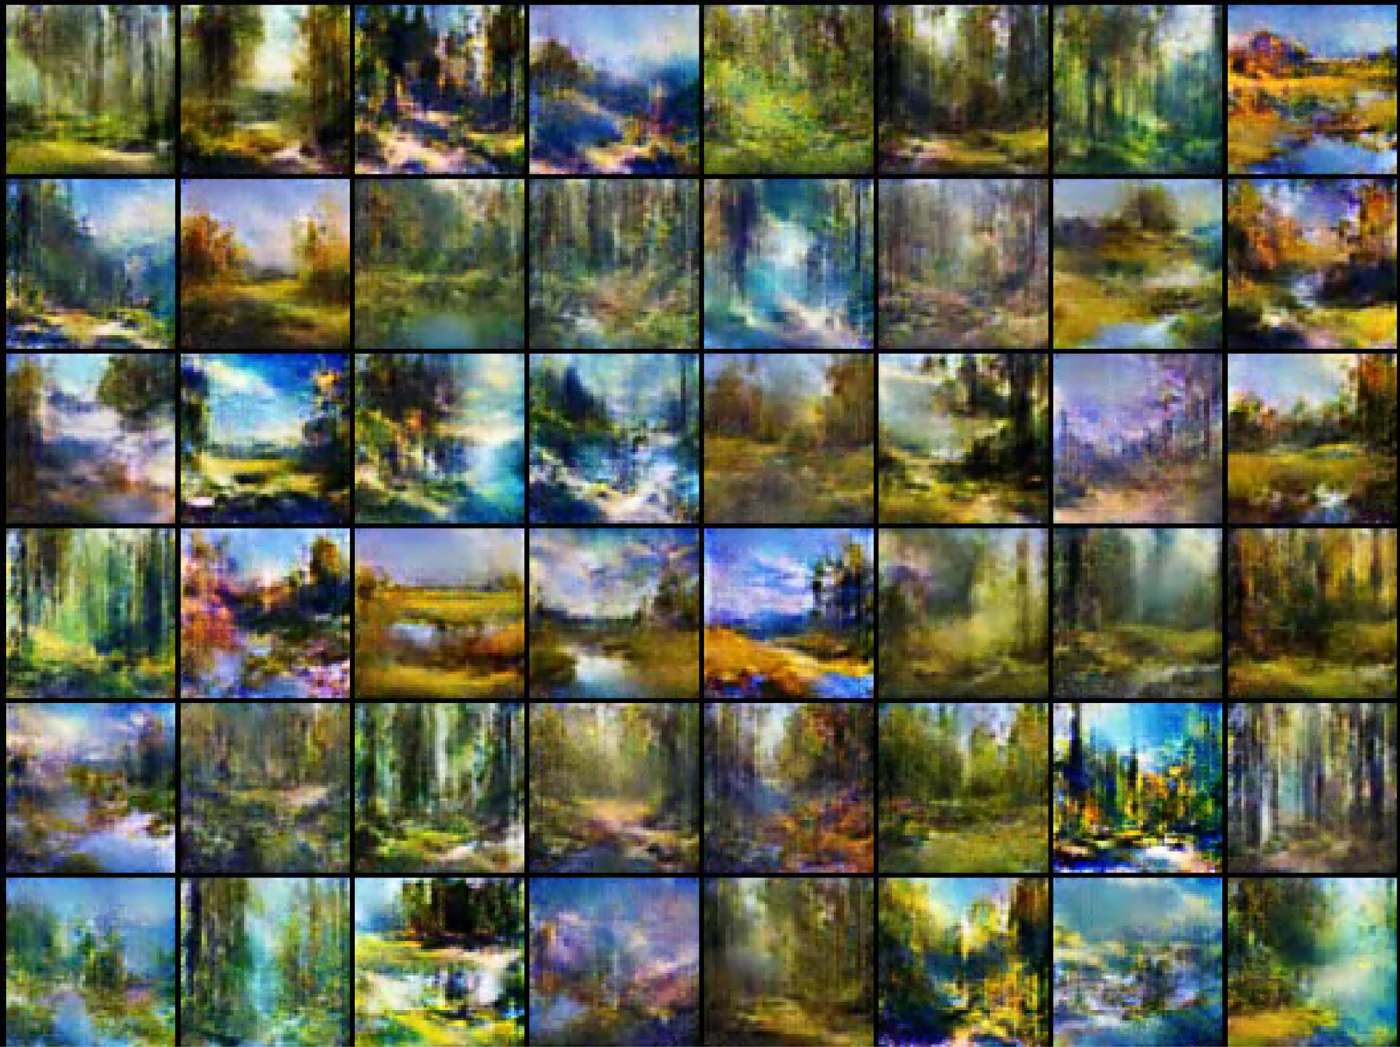

*Figure 24: Image revealing the training process of GAN at over 600 epochs*

Figure 25 reveals the final results from GAN which has reached 740 epochs from the training. Bylooking at these results, certain patterns have emerged. We can see that it appears that GAN tends to organize these images into distinct clusters based on their similarities. As seen in Figure 26, a few examples of groupings on the output based on their similarities has been produced.

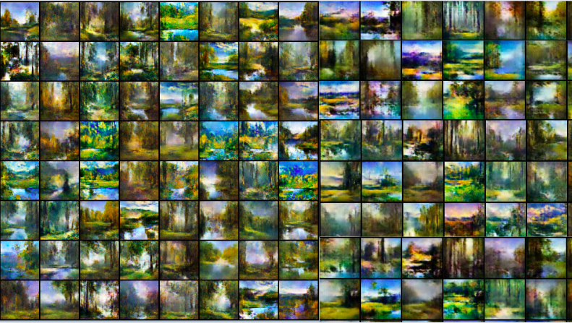

*Figure 25: Image revealing the results of GAN*

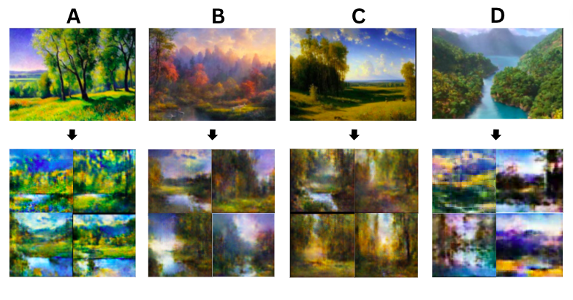

*Figure 26: Diagram revealing the insights of GAN*

Therefore, the results provide a clear indication on the function of GAN where as mentioned above, it tends to blend the qualities of individual input images together, seemingly in groups based on the proximity of the input image. Thus, a limitation of GAN would be the fact that the images don’t look surprising different. GAN does not mix elements from different groups, for instance group a and b in figure 16 to produce images that look very innovative.

The second limitation would be the fact that the images are still very blurry. This is due to the fac that it is done by one computer which is not made to professionally train AI models as well as with a short training period. Thus, there is a limited resolution. This is still a preliminary technique that is still work in progress, so the implementation has not been optimized

Additionally, another limitation would be that there is very little control over what we want the output images to look like, it just tends to blend the qualities of the original photoset randomly. We are unable to control the subject matter of the images. Therefore, this leads to a necessity to explore the third method, cycle GAN.

Cycle GAN functions similarly to GAN. However, instead there would be two sets of images, which are real image A and real image B as seen in Figure 27. Real image A would be the images that are inputted, which would receive the changes. In the case of this project, it would be some random images that are not necessarily calming represented on the top left of Figure 27. In real image B it is the qualities that Real image A would learn from. The generator would then generate images that have the basic components of real image A as seen here. In other words, the generator would learn any random images to a style closer to calming images.

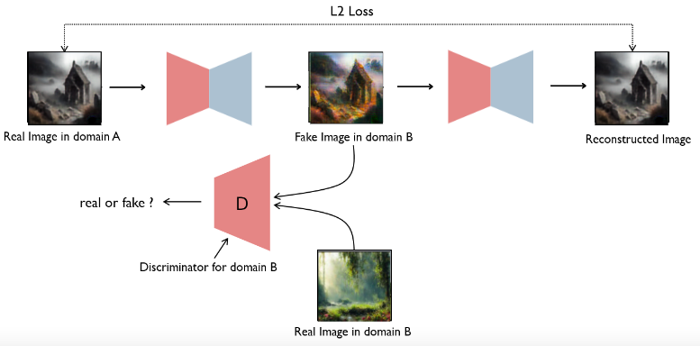

*Figure 27: Diagram explaining the concept of Cycle GAN*

Figure 28 provides a glimpse of a code that was partially used for Cycle GAN which was also retrieved from Kaggle. Minor alterations were made, input file where Real image B has also been changed to the dataset of 500 calming images previously generated by AI (refer to Figure 18). The real image A in this case would be the default image dataset of 7000 images which came with the kaggle package.

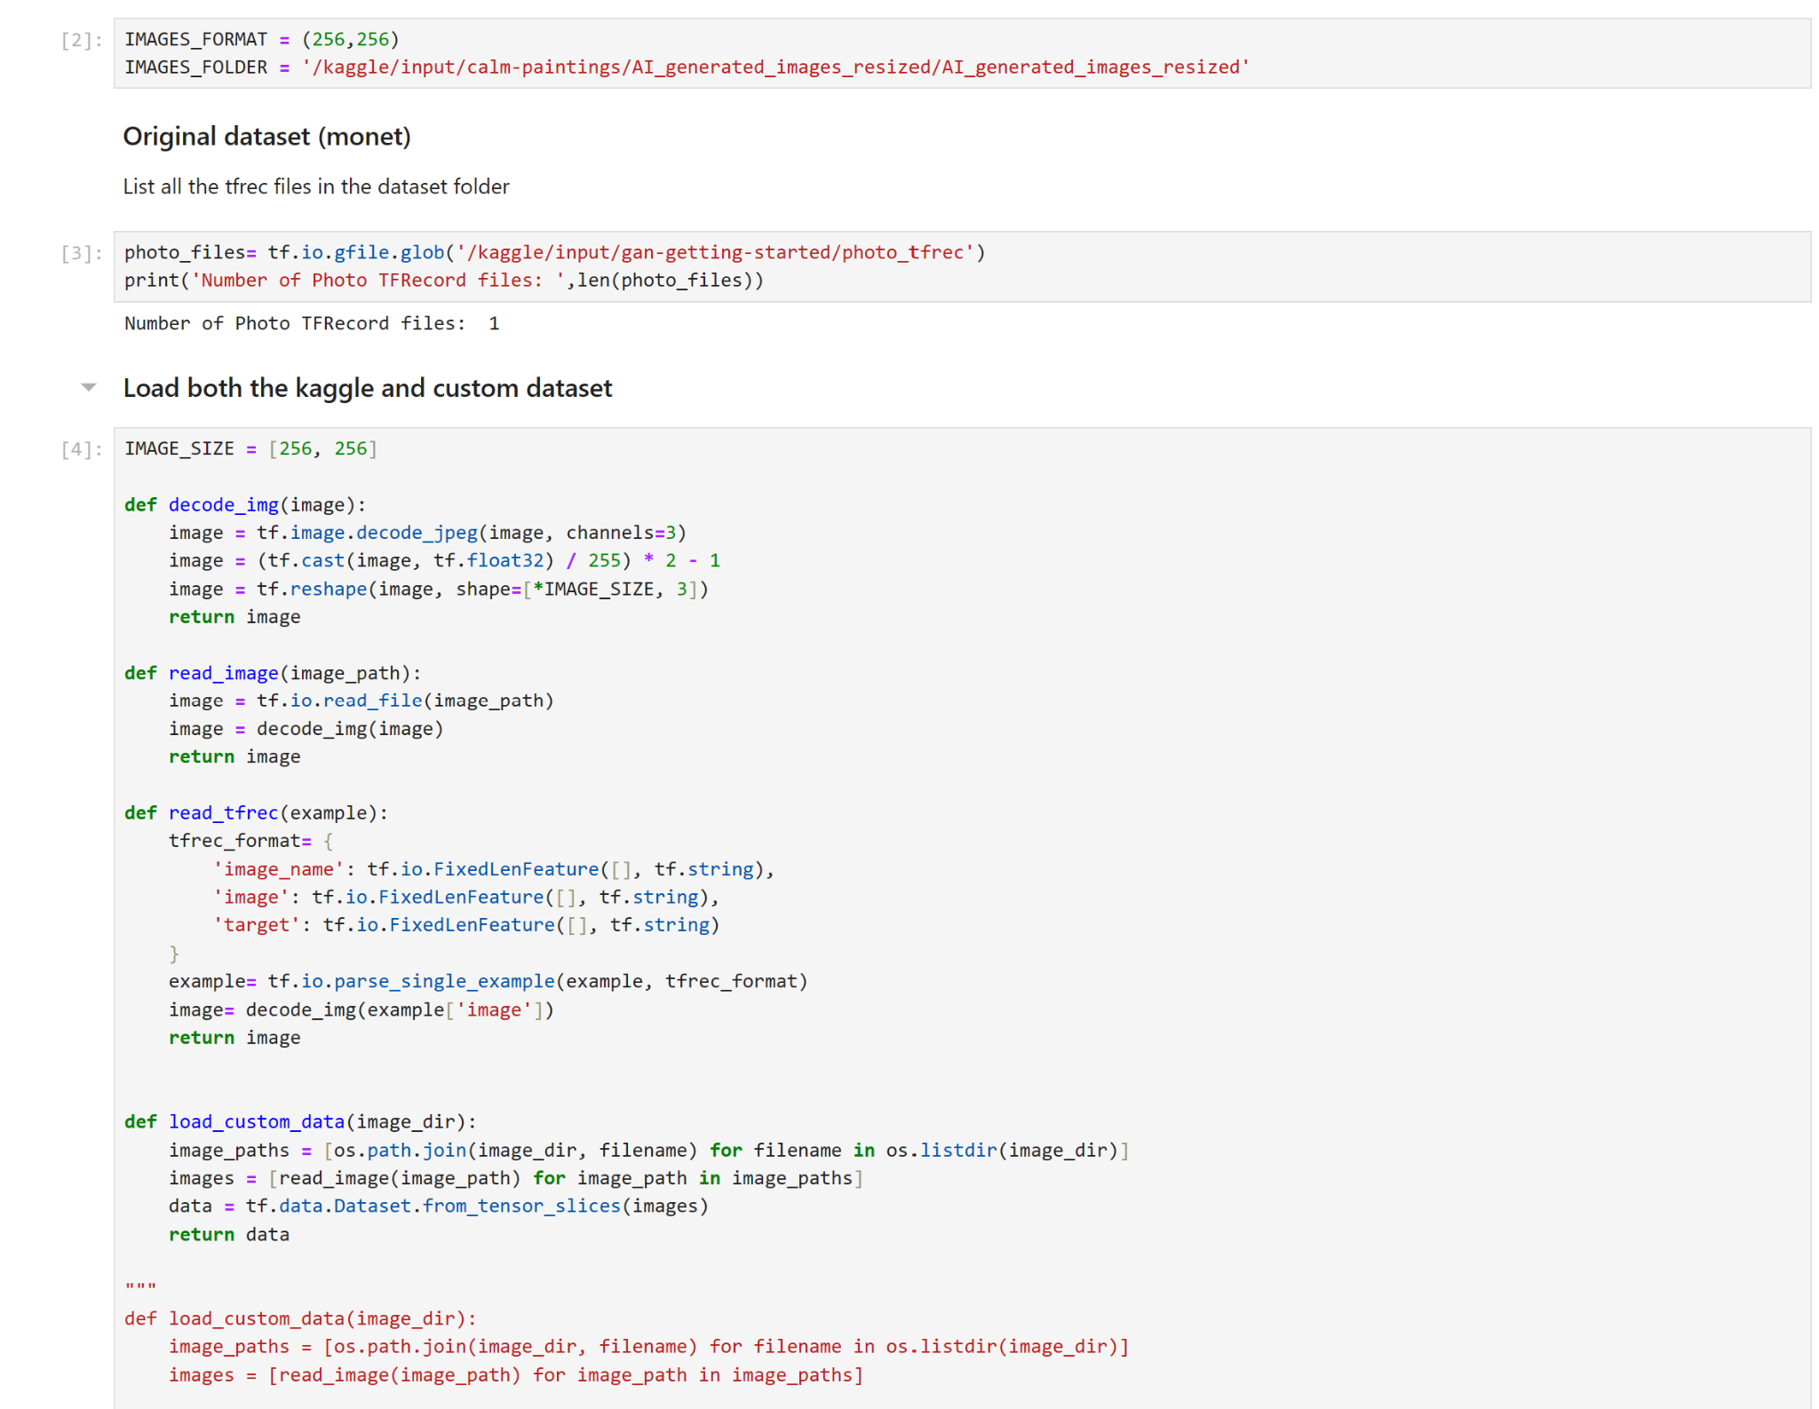

*Figure 28: Dataset loading for Cycle GAN*

Figure 29 shows some of the results of cycle GAN . As seen, A is the input, and would be converted to the output of B, having gone through the generator. The images pointing towards the generator are the calming images, indicating how these are also the input for generator, in order for output B to gain its style upon going through the generator. Image A, ( default images from kaggle) are the input Real image A. As seen in the results, the third image B counting from right to left in my personal opinion has the optimal transformation, where not only the colors has been transformed with more proximity of the color palettes of the calming images, but grass and trees in the background have also been added, matching the subject matter of the calming images more.

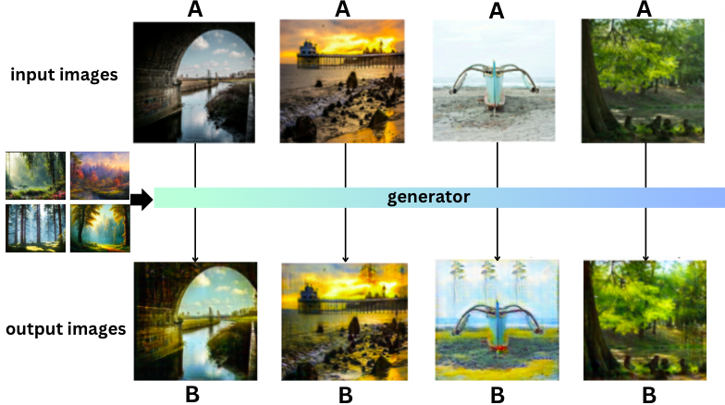

*Figure 29: Diagram explaining the results of Cycle GAN*

Additionally, for more investigation, the code has been modified to reveal up to 400 results instead of less than 15 outputs, where outputs of nature landscape are selected for further analysis as seen in Figure 30. This is to observe how Cycle GAN transforms input images that already have the subject matter similar to that of the 500+ “calming images”. It could be noticed that, the further away the color palette of the image A is from the calming images, the more room there is for Cycle GAN to perform its transformation. This example can be seen in the images at the bottom right of Figure 30 where more greens and blues as well as yellow green are installed, resembling the calming images more instead of the dull blue and brown tree sticks seen in the original A.

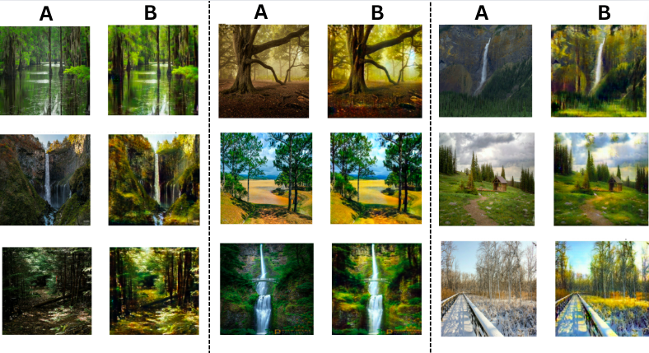

*Figure 30: Diagram explaining the results of Cycle GAN*

More investigation on the ability of Cycle GAN has been conducted through changing the default file that was embedded in the kaggle file. Instead of the default 7000 images, around 500 of random seemingly depressing images were generated by Ai. A small section of the 500 images could be seen in Figure 31 as an example.

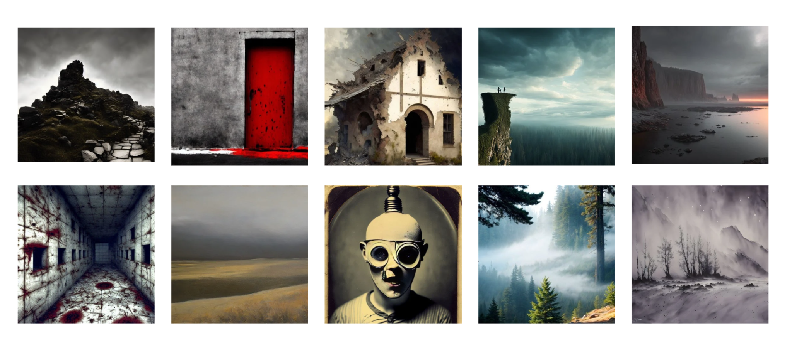

*Figure 31: Demonstration of depressed images generated by Ai*

Proceeding, out of a pool of output images, images that are not related to nature and with color palettes drastically different from the calming image dataset, such as images in black and white were selected for analysis. This could be referred to in Figure 32. It could be seen that Cycle GAN performs similarly as a filter, not failing to install nature like colors following my calming images into the right places in the output. For instance the light blue in the sky, green or earth brown is the subject of the image.

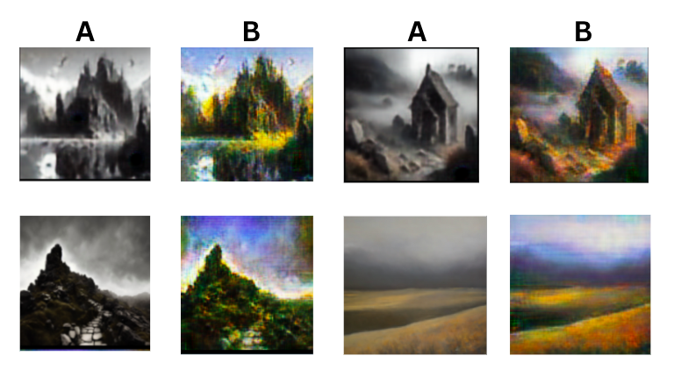

*Figure 32:Diagram explaining the results of Cycle GAN*

Another batch of images from the input of depressing images were selected for analysis in figure 33. It could be seen that the output images B does not look any more calming despite Cycle GAN having performed a filter on the images. A clear limitation of Cycle GAN is shown, it is not able to convert any images to be more calming when the subject deviates too much from the calming subjects based on research, for instance a human face with his eyes covered as seen in figure 33.

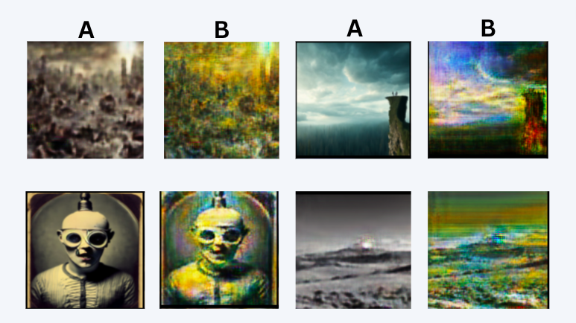

*Figure 33:Diagram explaining the results of Cycle Gan*

Another curious insight that has been briefly touched upon would be generated through a model that learns to transform images in the reversed direction which means calming to depressing images as seen in Figure 34. In this case, the results of gloominess as output would almost always be achieved.

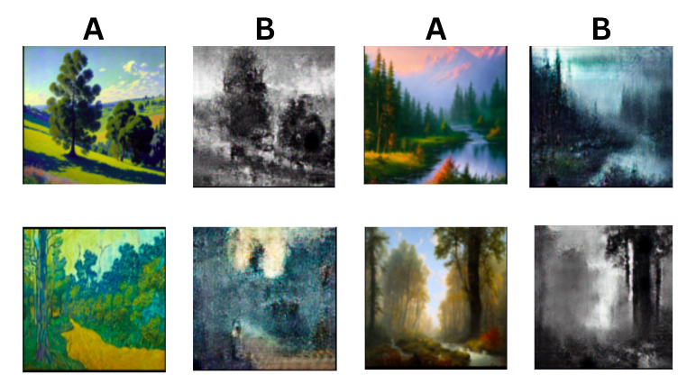

*Figure 34:Diagram explaining the results of reversed direction of Cycle GAN*

Regarding the general limitation of this project, there are a few crucial points. Firstly, there are more sophisticated methods like stable diffusion, which are text to image generators so the quality of the image could be better than GAN. However, the advantages of using GAN is that there is a more tailored way to specially generate images the way you want it.

Another limitation would be that, although research is used to back up the definition of elements that are objectively calming for different ages and gender, the concept of calming remains subjective and the results of the artwork outcomes may not please everyone.

The last limitation would be my own skills and timeframe. More image generation methods could be explored.

This would lead to the future outlook of the project, in the future, with more skills regarding Ai image generation acquired, perhaps the insights of the histogram could be used to help the model to train better, having the output images of GAN following the color scheme that is the guided by the insights of the histograms from Figure 13.

1.5 Summary

In summary, 3 methods, with 1 method of pretrained model and 2 methods of scratch trained model where different degrees of control on the output could be seen. From minimal control with text to image generator, to having a lot of control with the Cycle GAN given its nature of resembling an image filter. Yet all of them have their own advantages and disadvantages.

Ultimately, if the paintings created by volunteers are inspired by the output images of GAN or if the output images were to be printed and placed directly in a hospital, ideally this would be how it looks like. This could potentially enlighten the monotonous environment of a hospital just by adding some variation of colors and subjects that are calming to look at based on research. This would be useful especially for rooms without a big window visible. Additionally, it allows the overall environment to be less“prison” like an environment.

Figure 35

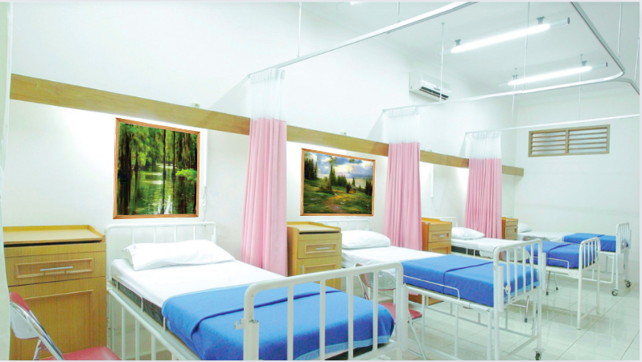

*Figure 35: Photoshopped image of the display of potential results*

References:

*Microsoft Research Limited Fund*. Cambridgeshire Community Foundation. (2024, May 15). https://www.cambscf.org.uk/microsoft-research-limited-fund

Made Simple Media | www.madesimplemedia.co.uk | info@madesimplemedia.co.uk. (n.d.-b). *Our art collection*. Imperial Health Charity. https://www.imperialcharity.org.uk/arts/the-collection

*Public art online: The leading public art resource*. Public Art Online Resources - Advice for the healthcare sector - When the Architects Leave: Maintaining artwork in the hospital environment. (n.d.-a). https://publicartonline.org.uk/resources/practicaladvice/advicehealthcare/hospital_artwork_maintenance.php.html

Nielsen, S. L., Fich, L. B., Roessler, K. K., & Mullins, M. F. (2017a, December). *How do patients actually experience and use art in hospitals? the significance of interaction: A user-oriented experimental case study*. International journal of qualitative studies on health and well-being. https://www.ncbi.nlm.nih.gov/pmc/articles/PMC5328392/

Ulrich R.(1993) *The biophilia hypothesis.* Washington, DC: Island Press; https://www.researchgate.net/publication/284655696_Biophilia_biophobia_and_natural_landscapes

Jo, H., Ikei, H., & Miyazaki, Y. (2022). Physiological and Psychological Benefits of Viewing an Autumn Foliage Mountain Landscape Image among Young Women. *Forests*, *13*(9), 1492. <https://doi.org/10.3390/f13091492>

Igarashi M;Song C;Ikei H;Ohira T;Miyazaki Y; (n.d.). *Effect of olfactory stimulation by fresh rose flowers on autonomic nervous activity*. Journal of alternative and complementary medicine (New York, N.Y.). https://pubmed.ncbi.nlm.nih.gov/25055057/

A study of the effects of visual and Performing Arts in health ... (n.d.-a). https://publicartonline.org.uk/resources/research/documents/ChelseaAndWestminsterResearchproject.pdf

1. *Microsoft Research Limited Fund*. Cambridgeshire Community Foundation. (2024, May 15). https://www.cambscf.org.uk/microsoft-research-limited-fund
2. Made Simple Media | www.madesimplemedia.co.uk | info@madesimplemedia.co.uk. (n.d.-b). *Our art collection*. Imperial Health Charity. https://www.imperialcharity.org.uk/arts/the-collection
3. *Public art online: The leading public art resource*. Public Art Online Resources - Advice for the healthcare sector - When the Architects Leave: Maintaining artwork in the hospital environment. (n.d.-a). https://publicartonline.org.uk/resources/practicaladvice/advicehealthcare/hospital_artwork_maintenance.php.html
4. Nielsen, S. L., Fich, L. B., Roessler, K. K., & Mullins, M. F. (2017a, December). *How do patients actually experience and use art in hospitals? the significance of interaction: A user-oriented experimental case study*. International journal of qualitative studies on health and well-being. https://www.ncbi.nlm.nih.gov/pmc/articles/PMC5328392/
5. Ulrich R.(1993) *The biophilia hypothesis.* Washington, DC: Island Press; https://www.researchgate.net/publication/284655696_Biophilia_biophobia_and_natural_landscapes
6. Jo, H., Ikei, H., & Miyazaki, Y. (2022). Physiological and Psychological Benefits of Viewing an Autumn Foliage Mountain Landscape Image among Young Women. *Forests*, *13*(9), 1492. <https://doi.org/10.3390/f13091492>
7. Igarashi M;Song C;Ikei H;Ohira T;Miyazaki Y; (n.d.). *Effect of olfactory stimulation by fresh rose flowers on autonomic nervous activity*. Journal of alternative and complementary medicine (New York, N.Y.). https://pubmed.ncbi.nlm.nih.gov/25055057/
8. X, S. (2023, March 27). *Study reveals that art has a powerful effect on people’s bodies and emotions*. Medical Xpress - medical research advances and health news. https://medicalxpress.com/news/2023-03-reveals-art-powerful-effect-people.html#:~:text=A%20new%20study%20reveals%20how%20viewing%20visual%20art,subjects%27%20eye%20movement%20while%20they%20viewed%20the%20art.
9. A study of the effects of visual and Performing Arts in health ... (n.d.-a). https://publicartonline.org.uk/resources/research/documents/ChelseaAndWestminsterResearchproject.pdf